Supplementary tables.

Figure 1. MRI hand protocols for TASOAC study.
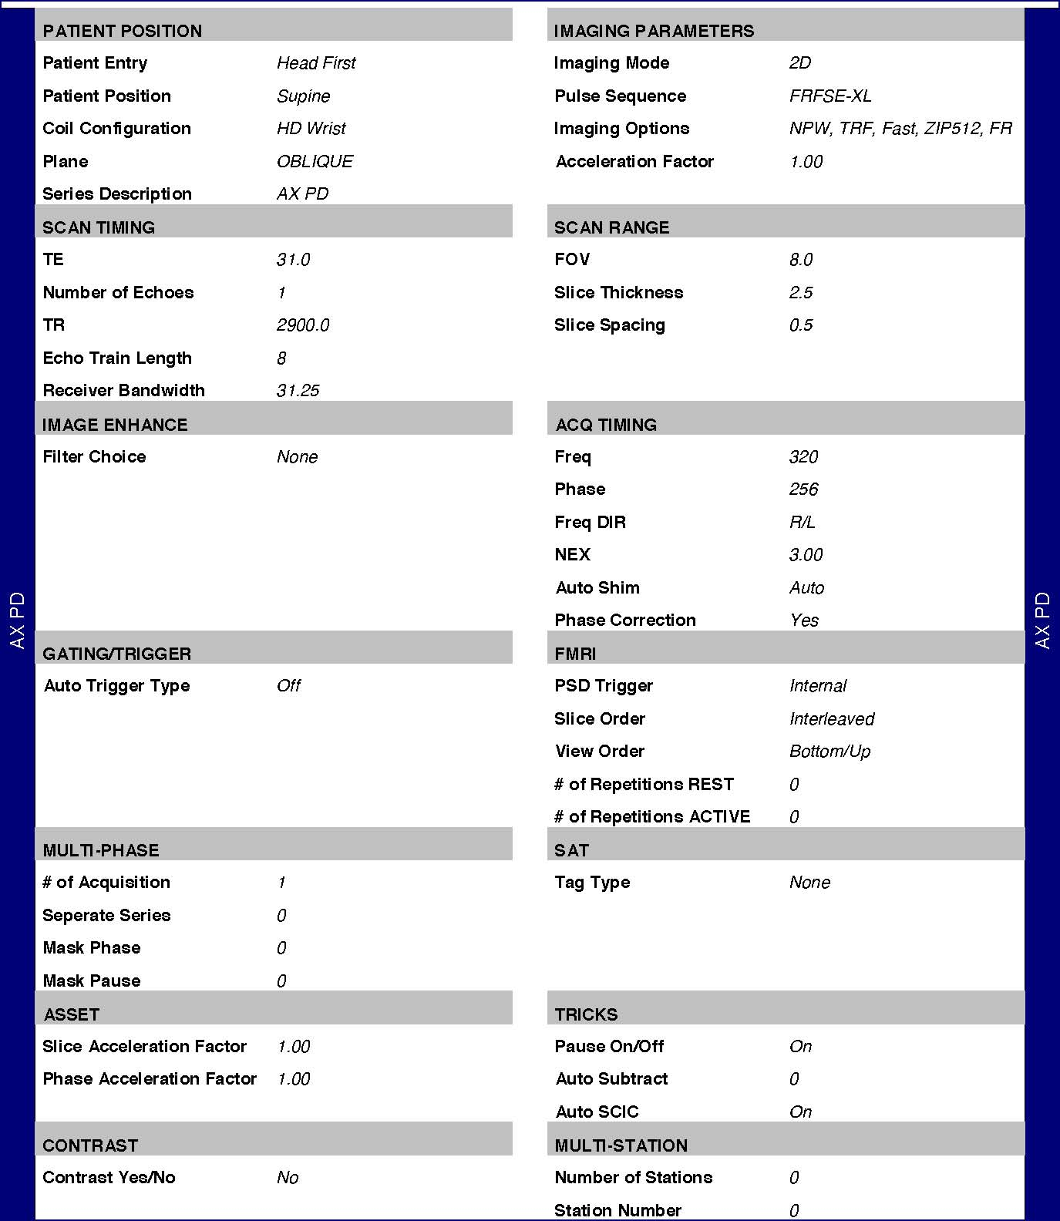
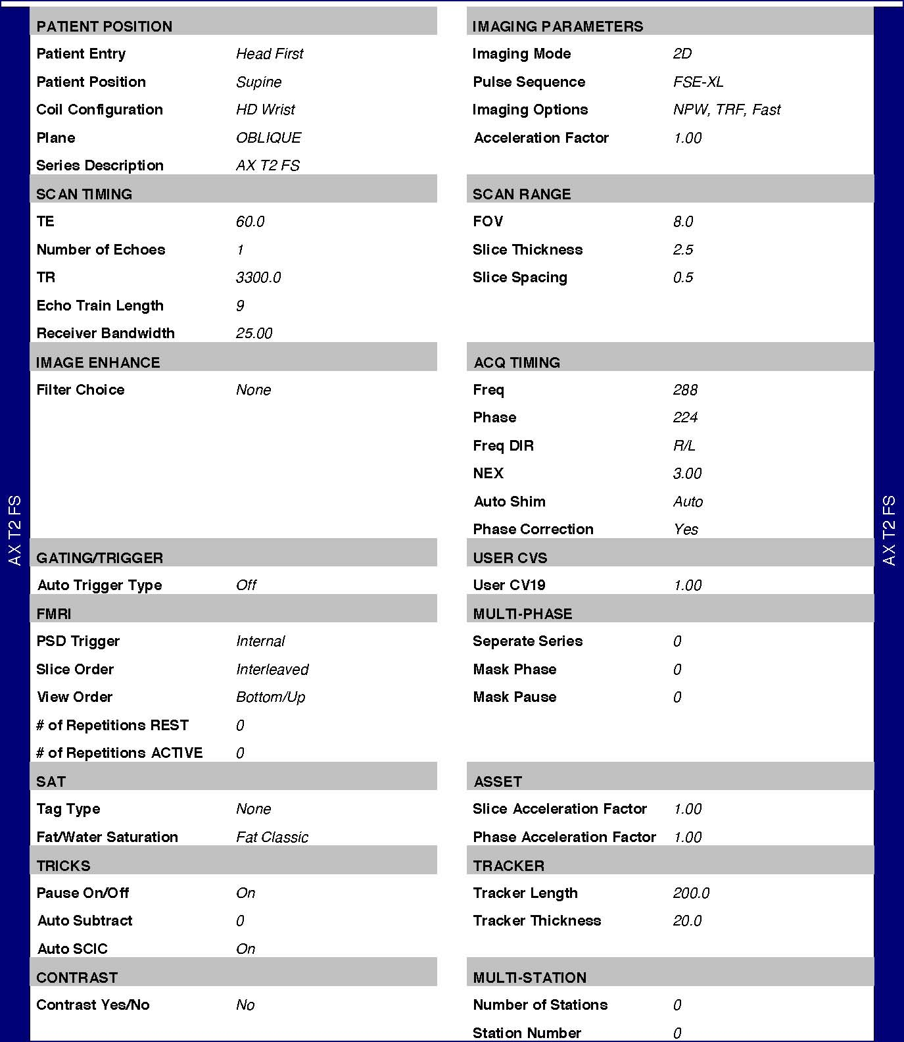
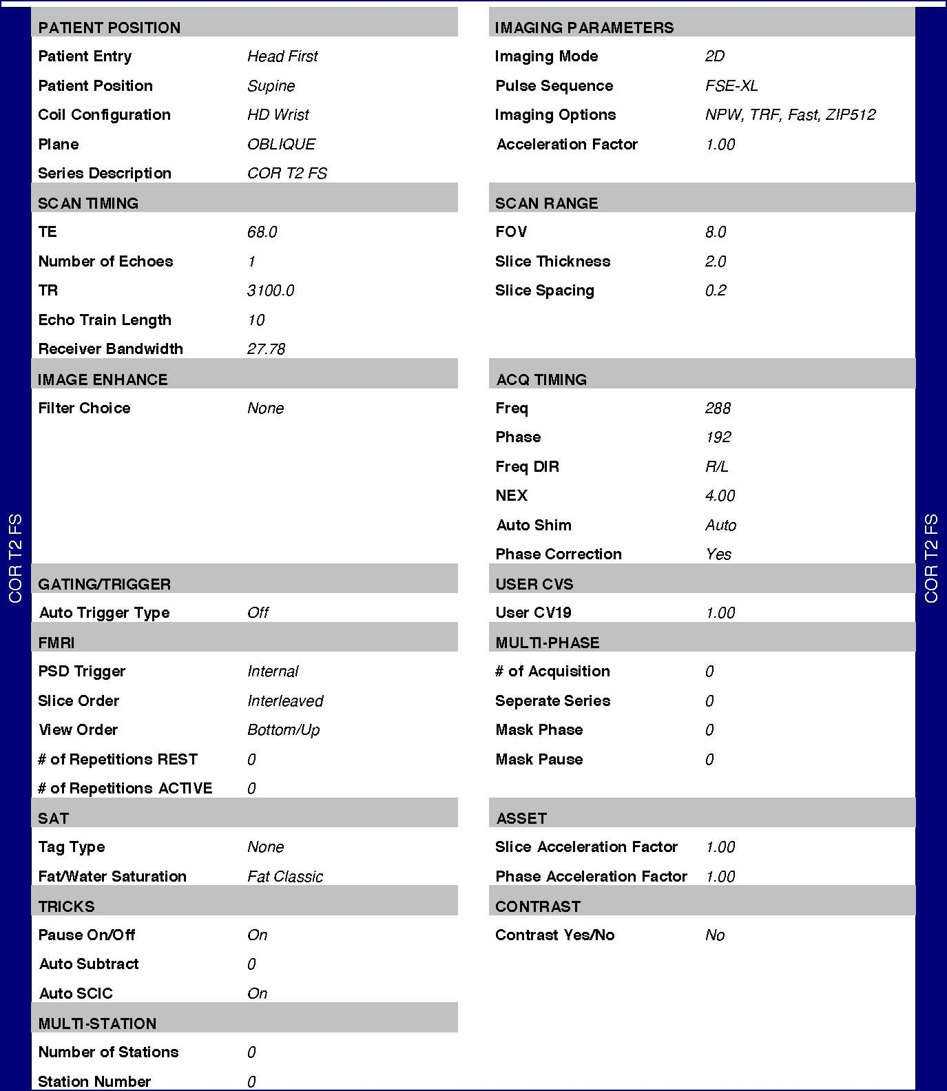
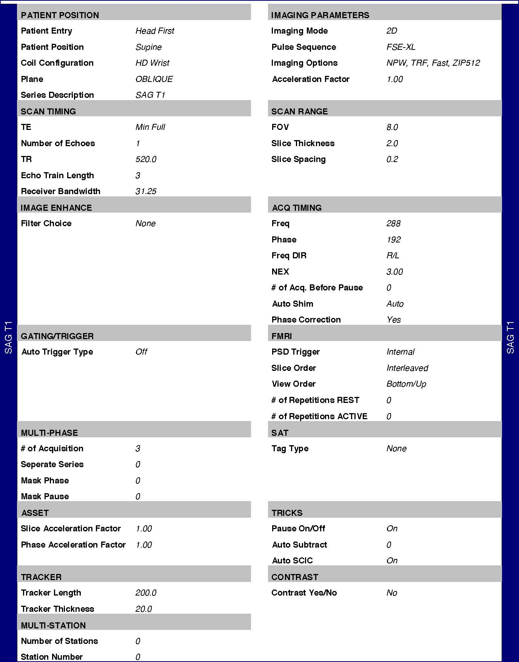
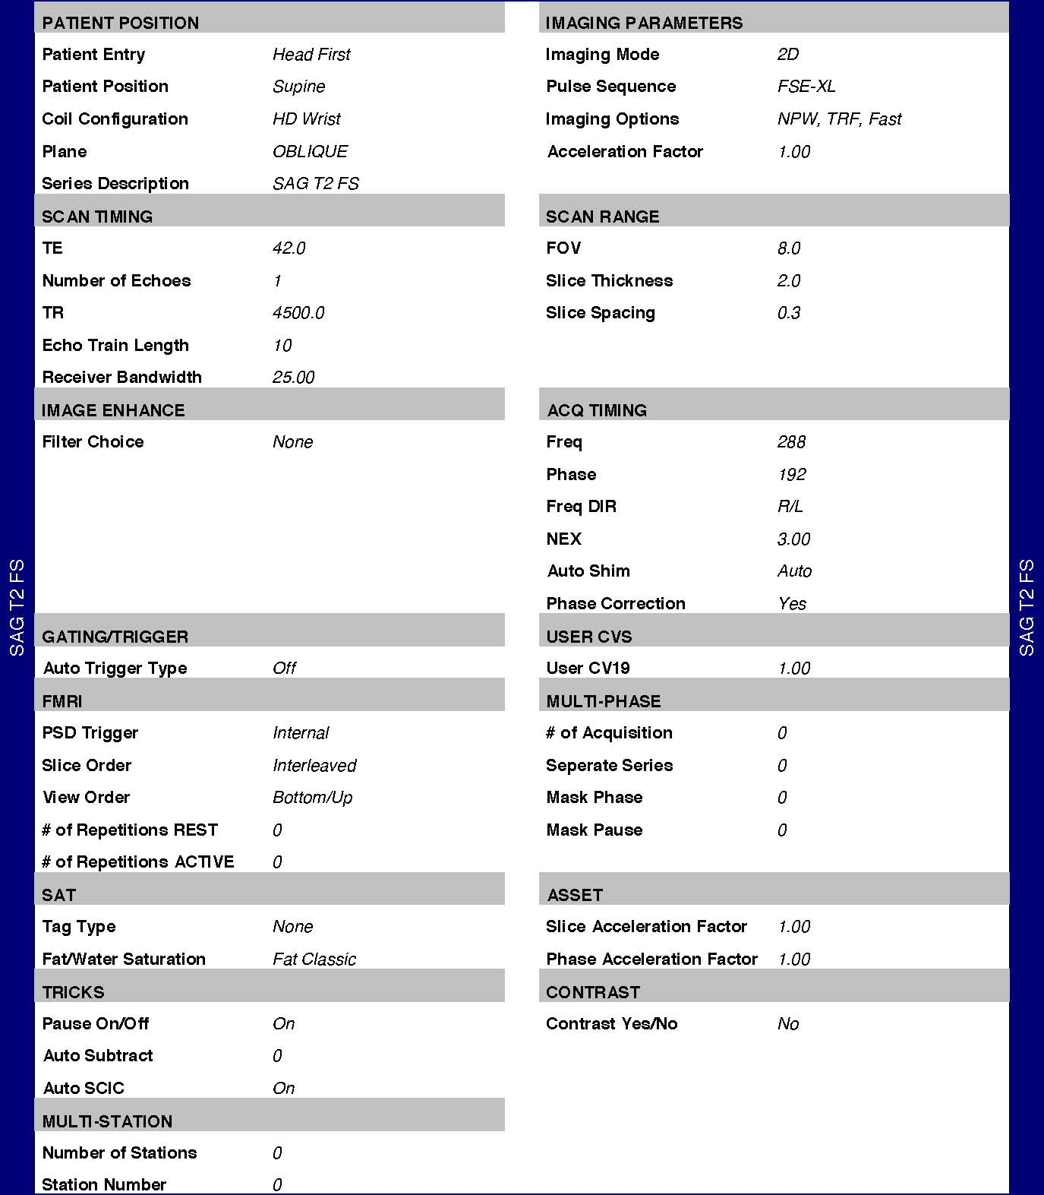

Table 1. Intra-rater reliability test for hand MRI abnormalities (n=40).
Abnormalities | Joint | Kappa value *
Effusion | DIP | Cannot be determined
 | PIP | 0.625 (0.243, 1.00)
Absence of collateral ligament | DIP | Cannot be determined
 | PIP | Cannot be determined
Bone marrow lesion | DIP | 0.884 (0.468, 0.891)
 | PIP | 0.788 (0.468, 0.891)
Erosion | DIP | 0.644 (0.556, 0.76)
 | PIP | 0.510 (0.266, 0.623)
Osteophytes | DIP | 0.741 (0.554, 0.823)
 | PIP | Cannot be determined
Kappa value (CI)
*kappa value for bone marrow lesions, erosion, and osteophytes were determined using weighted kappa.

Table 2. Associations of MRI/X-ray abnormalities at the index finger joints and categorical total AUSCAN scores.
 | Total AUSCAN score
Adjusted for | age and sex  OR (95% CI) | + all other MRI/X-ray abnormalities  OR (95% CI)
MRI abnormalities…
Effusion | 0.52 (0.26, 1.05) | 0.53 (0.26, 1.05)
Absence of CL | 2.39 (0.81, 7.10) | 2.39 (0.80, 7.12)
BML | 1.00 (0.67, 1.54) | 1.04 (0.62, 1.75)
Erosion | 0.86 (0.57, 1.30) | 0.72 (0.42, 1.21)
Osteophytes | 1.33 (0.84, 2.13) | 1.34 (0.80, 2.26)
No. of MRI abnormalities | 0.81 (0.55, 1.21) | -
X-ray abnormalities…
Osteophytes | 0.98 (0.62, 1.54) | 0.84 (0.51, 1.39)
JSN | 1.68 (1.06, 2.65) | 1.75 (1.09, 2.82)
Associations were assessed using ordinal logistic regression treated with inverse probability weighting.
Total AUSCAN score was categorised at none, below, and above median.
No. of MRI abnormalities were dichotomised at the median (3).
AUSCAN, Australian/Canadian hand osteoarthritis index; OR, odds ratio; CI, confidence interval; MRI, magnetic resonance imaging; RR, relative risk; CI, confidence interval; CL, collateral ligament; BML, bone marrow lesions; JSN, joint space narrowing.
Bold denotes a statistically significant result.

